|  |  |
| --- | --- |
| **STUDENT PORTFOLIO** | |
| Insert Photo | **Name: A. l. v. Gayathri.**  **Register Number: RA2211028010207**  **Mail ID: ga9746@srmist.edu.in**  **Department: CSE**  **Specialization: Cloud Computing**  **Semester: 1** |
| **Subject Title: Programming for problem solving**  **Handled By: DR P BALAMURUGAN** | |
| **Assignment**  **Assignment questions are based on line wise like topic wised and I had solved them based on the space and time complex ability.** | |
| **Assignment**  **Using arrays and loops in coding is interesting part in my assignment.** | |
| **MINI PROJECT REPORT**    **Mini project is to build Tourism Management System using C program. In**  **this project we have to enter Number of passengers and with their details and the given destination was selected with indeed package and service if required extra package is available (with extra charges).** | |
|  | |

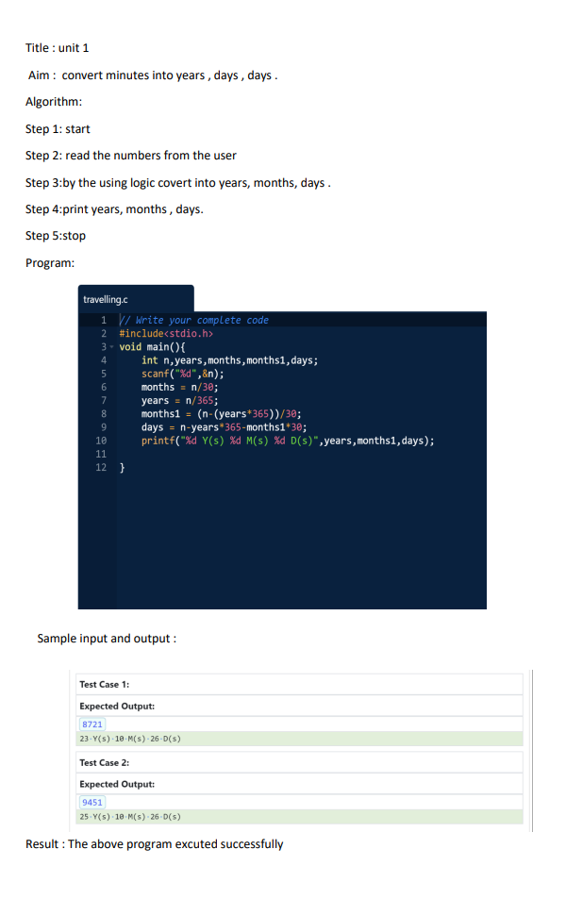

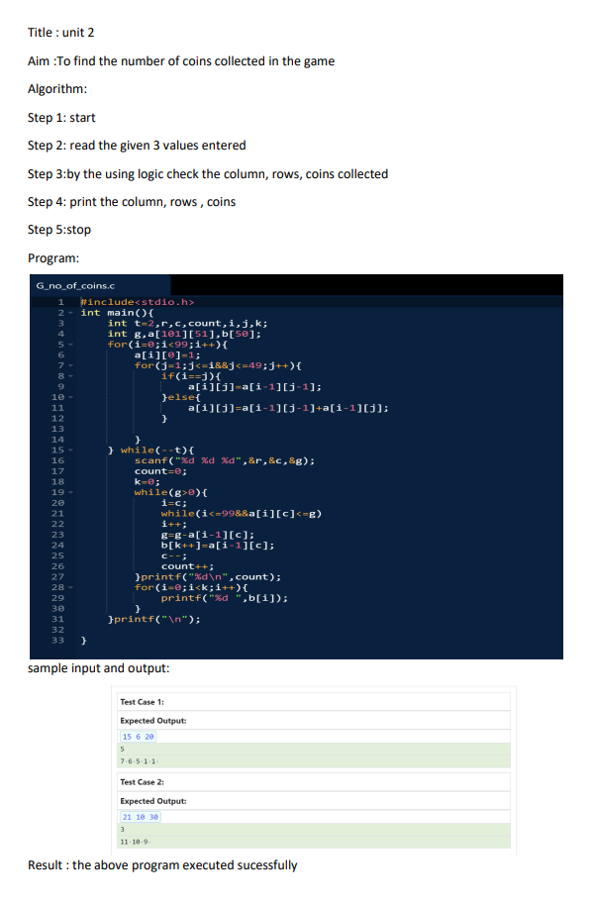

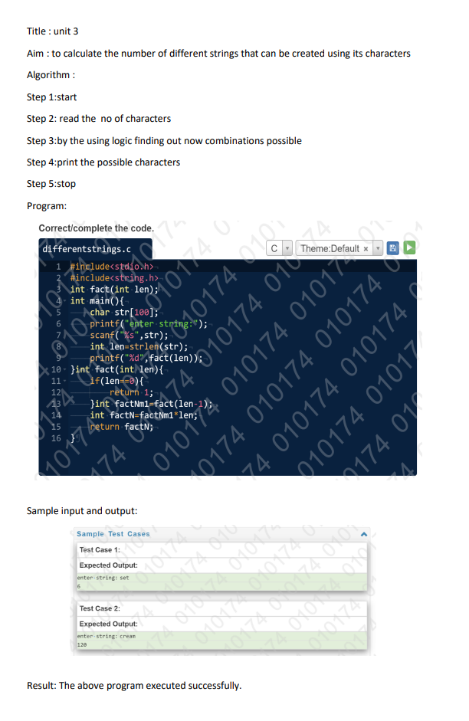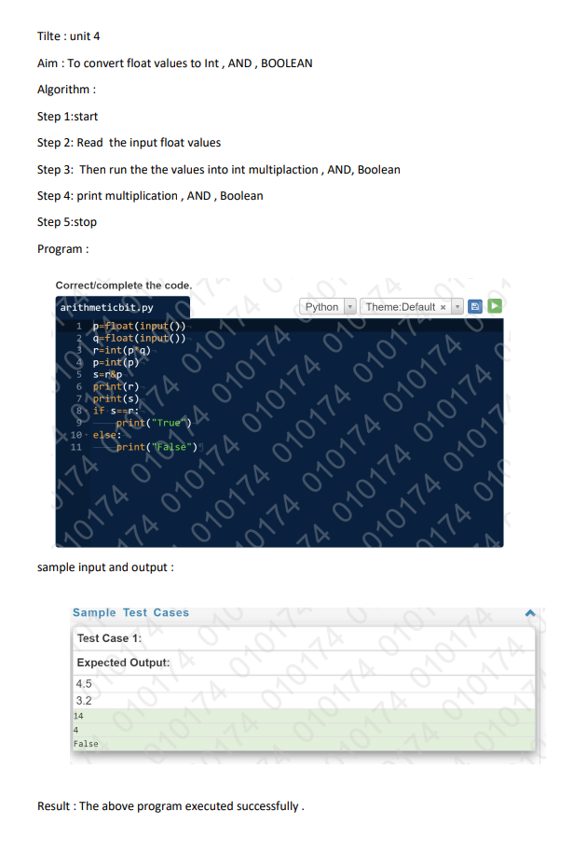

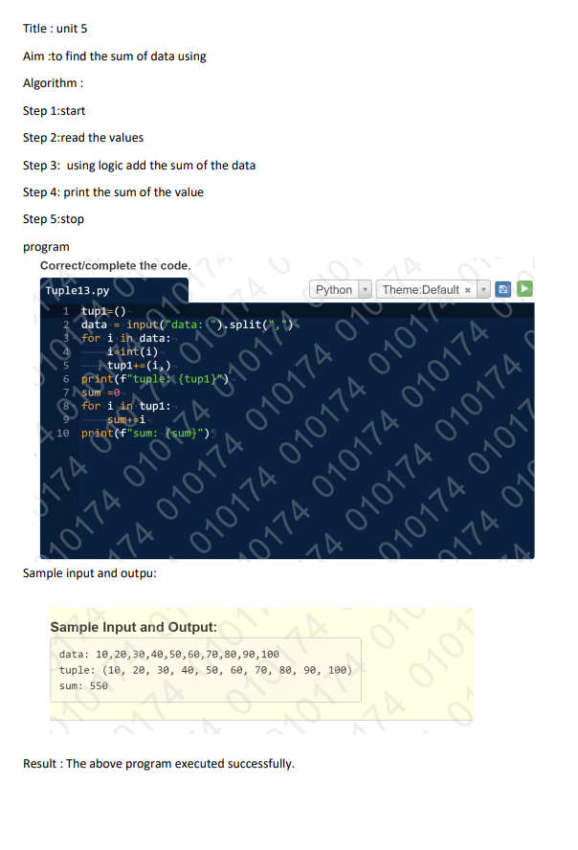

|  |
| --- |
| **TOURISM MANAGEMENT SYSTEM**  **21CSS101J – PROGRAMMING FOR PROBLEM SOLVING**  **Mini Project Report**  *Submitted by*  **Student Name :GAYATHRI ANNAM**  **Reg. No.: RA2211028010207**  **B.Tech. CSE - CLOUD COMPUTING**  **Student Name :SHANE SUNNY KOTTUPPALLIL**  **Reg. No.: RA2211028010211**  **B.Tech. CSE - CLOUD COMPUTING**  **SRMIST-01.jpg**  **SCHOOL OF COMPUTING**  **COLLEGE OF ENGINEERING AND TECHNOLOGY**  **SRM INSTITUTE OF SCIENCE AND TECHNOLOGY**  **(Under Section 3 of UGC Act, 1956)**  S.R.M. NAGAR, KATTANKULATHUR – 603 203  KANCHEEPURAM DISTRICT  **December 2022** |

**TABLE OF CONTENTS**

|  |  |  |
| --- | --- | --- |
| **Chapter No.** | **Title** | **Page No.** |
| 1 | Problem Statement | **1-2** |
| 2 | Methodology / Procedure | **3-4** |
| 3 | Coding (C or Python) | **5-14** |
| 4 | Results | **14-18** |
| 5 | Conclusion | **19** |

***PROBLEM STATEMENT***

1

WRITE A C PROGRAM FOR TOURISM MANAGEMENT SYSTEM

THIS PROGRAM SHOULD CONTAIN:

1. FIRST GET THE NUMBER OF TOURISTS.THEN MAKE A LOOP SO THAT THE PROGRAM SHOULD CONTAIN THE CODE TO GET THE FIRST NAME,LAST NAME, GENDER,CONTACT NUMBER AND AGE.
2. THIS PROGRAM ITSELF SHOWS SOME TOURIST DESTINATIONS THAT THE SYSTEM PROVIDES WHICH INCLUDES DELHI, GOA, KERALA, ANDHRA PRADESH, KASHMIR.
3. ALLOW THE USER TO CHOOSE THEIR PREFERRED DESTINATION.
4. AFTER PICKING UP THE TOURIST DESTINATION PRINT THE

TOURIST PACKAGE WHICH INCLUDE TRAVEL,STAY,FOOD AND OTHER SERVICE EXPENSES WITH AND WITHOUT GST.

1. ASK THE USER WHETHER THEY PREFER EXTRA SERVICES OR NOT.

2

1. ASK THE NUMBER OF DAYS THE PREFER TO SPEND AND LATER MULTIPLY THOSE DAYS WITH THE TOTAL AMOUNT PER DAY TO PRINT THE FINAL AMOUNT.

***Methodology/Procedure :***

3

1)Start

2)Declare and Intialise three arrays

name[20],name1[20],gender[35]

3)Get the value of number of Passengers from the user.

4)Declare and Initialise six Integer type variable

no_of_members,starting_date,returning_date,no_

of_days,final,answer

5)Take the value of First Name,Last Name,Gender,Age,Contact

number.

6)Print these Values.Repeat these process using for loop.

7)Enter the destinations for the user to select.

8)Ask the user to select their destination from the given options.

9)Define some tourist packages within the program with their specific amount which includes the Travel ,Food,Stay Expenses and other sevices.

10)Ask the user to enter the Starting date and the Returning Date.

4

11)Take the value of number of days.

12)Multiply the amount for each day of stay with the number of days.

13)Ask the user whether they need Extra Services(If needed 300).

14)Print the total amount including GST.

15)Stop

***CODING:***

5

C PROGRAM:

#include<stdio.h>

int main()

{

printf("...\t\t\t\t\tSHANESREE TOURISM

REGISTRATION\t\t\t\t\t...\n\n");

printf("\n\n");

int no_of_members,starting_date,returning_date,no_

of_days,final,answer;

printf("Enter the number of passengers : ");

scanf("%d",&no_of_members);

for(int i=1;i<=no_of_members;i++)

{

char name[20],name1[20],gender[35]; int age;

int a;

double contact_number; printf("Enter First Name : ");

6

scanf("%s",name); printf("Enter Last Name : ");

scanf("%s",name1); printf("Enter gender :"); scanf("%s",gender);

printf("Enter age :"); scanf("%d",&age);

printf("Enter contact number : ");scanf("%lf",&contact_number);

printf("\n\t\t\t\tPASSENGER'S NAME : %s

%s\n",name,name1);

printf("\t\t\t\tPASSENGER'S GENDER :

%s\n",gender);

printf("\t\t\t\tPASSENGER'S AGE :

%d\n",age);

printf("\t\t\t\tPASSENGER'S CONTACT NUMBER :

%0.0lf\n",contact_number);

}

printf("\n\n....\t\t\t\tTOURIST

DESTINATIONS\t\t\t\t....\n\n");

printf("\t\t\t\t 1. DELHI \n\t\t\t\t 2. KERALA

7

\n\t\t\t\t 3. ANDHRA PRADESH \n\t\t\t\t 4. KASHMIR

\n\t\t\t\t 5. GOA \n");

int choice;

printf("Enter your choice : \n");

scanf("%d",&choice); if(choice==1)

{

printf("You have selected

DELHI.\n\n...\t\t\t\t\tAMOUNT\t\t\t\t\t...\n\nTotal Amount :- 3000(Without GST)\n1.Travels :-

700\n2.Foods

:- 1000\n3.Stays

:-

1300\n4.Services :- 300(Not

Compulsory)\n5.GST

final=3600;

}

if(choice==2)

{

8

:- 600\n\n");

printf("You have selected

KERALA.\n\n...\t\t\t\t\tAMOUNT\t\t\t\t\t...\n\nTo

tal Amount :- 5000(Without GST)\n1.Travels :-

Compulsory)\n5.GST

final=6000;

}

if(choice==3)

{

:- 1000\n\n");

printf("You have selected ANDHRA

PRADESH.\n\n...\t\t\t\t\tAMOUNT\t\t\t\t\t...\n\n

Total Amount :- 5000(Without GST)\n1.Travels :-

2000\n2.Foods

:- 1400\n3.Stays

:-

1400\n2.Foods

:- 1600\n3.Stays

:-

9

2000\n4.Services :- 300(Not1600\n4.Services :- 300(Not

Compulsory)\n5.GST

final=6000;

}

if(choice==4)

{

:- 1000\n\n");

printf("You have selected

KASHMIR.\n\n...\t\t\t\t\tAMOUNT\t\t\t\t\t...\n\n

Total Amount :- 4000(Without GST)\n1.Travels :-

Compulsory)\n5.GST

final=4800;

}

if(choice==5)

{

:- 800\n\n");

printf("You have selected

10

GOA.\n\n...\t\t\t\t\tAMOUNT\t\t\t\t\t...\n\nTotal

Amount :- 4500(Without GST)\n1.Travels :-

Compulsory)\n5.GST

final=5400;

:- 900\n\n");

1700\n2.Foods

:- 1000\n3.Stays

:-

1300\n4.Services :- 300(Not

1700\n2.Foods

:- 1500\n3.Stays

:-

1300\n4.Services :- 300(Not}

printf("Starting Date(DDMMYYYY) : ");

scanf("%d",&starting_date);

printf("Returning Date(DDMMYYYY) : ");

scanf("%d",&returning_date); printf("Number of

Days : "); scanf("%d",&no_of_days);

final=final*no_of_days;

11

printf("Extra Services Needed :

\n1.YES\n2.NO\nEnter Your Choice : ");

scanf("%d",&answer); if(answer==1)

{

final=final+300;

}

printf("\nFinal Amount To Be Paid : %d\n",final);

printf("\n\n...\t\t\t\t\tThank You For

Registering.\t\t\t\t\t...");

}********************************************

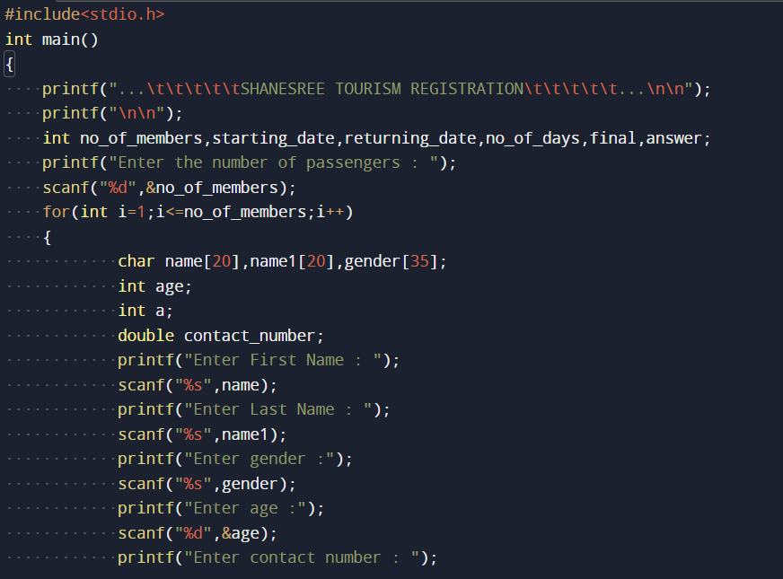

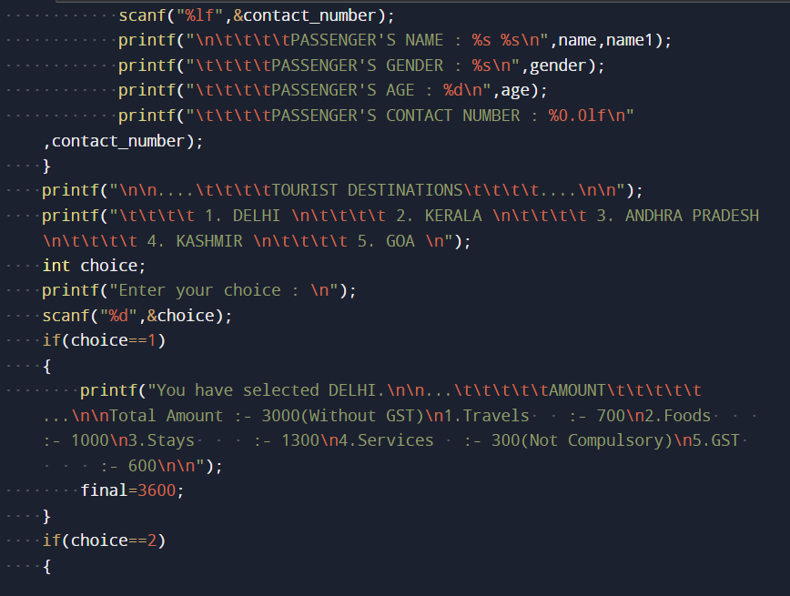

12

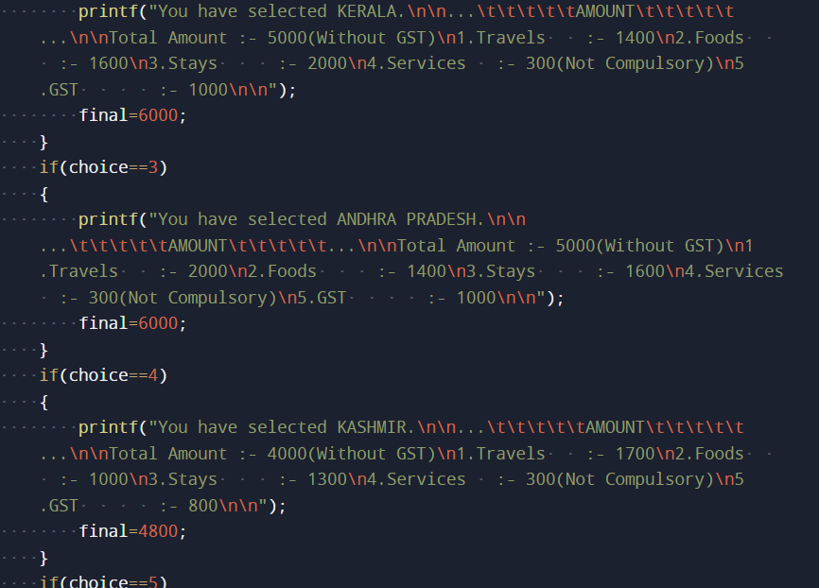

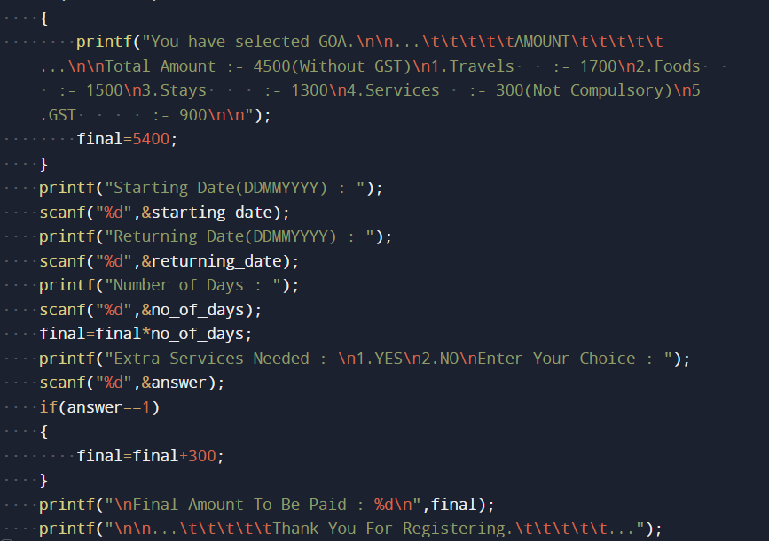

13

14

***RESULT :***

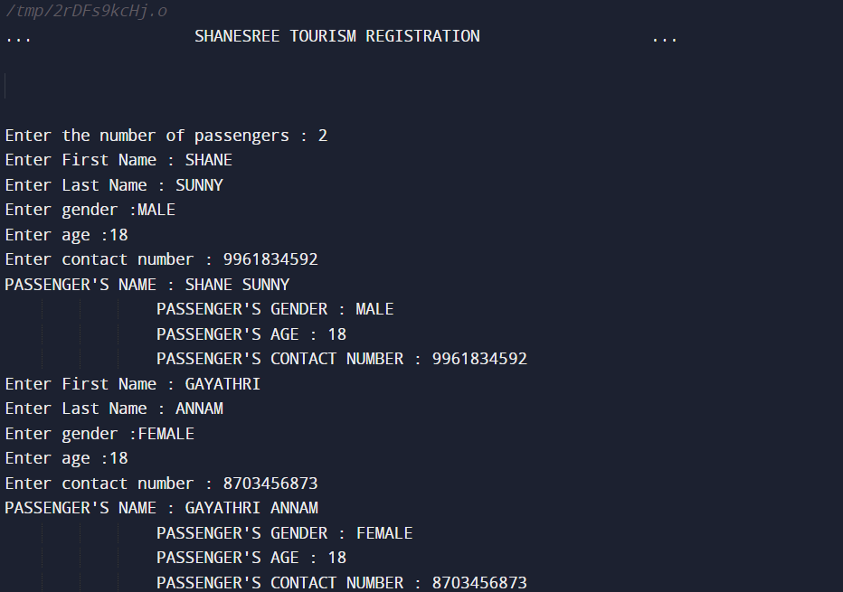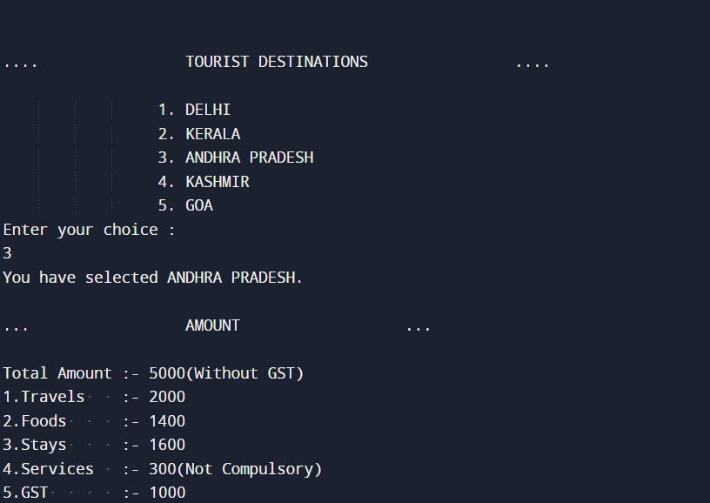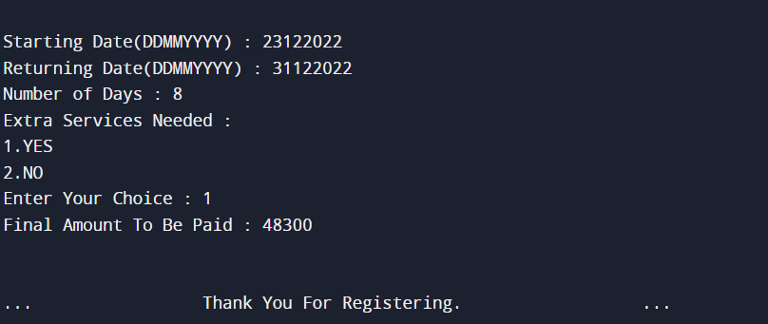

15

|  |  |  |  |  |  |  |  |  |  |  |  |  |  |  |  |
| --- | --- | --- | --- | --- | --- | --- | --- | --- | --- | --- | --- | --- | --- | --- | --- |
|  | 1. **l. v. Gayathri**   **Signature** | | | | | | | | | | | | |  | |
|  |  | |
|  |  | |
|  |  | |
|  |  | |
|  |  | |
|  |  | |
|  |  | |
|  |  |  |  |  |  |  |  |  |  |  |  |  |  | |
| **Note: Enclose the assignment and relevant certificates along with the profile** | | | | | | | | | | | | | | | |